ShopKomen.com Grantee access code: SGKGRANTEE2017

April 1, 2018

Dear Susan G. Komen® Grantee,

Thank you for your time and dedication in the fight against breast cancer. As you know, our mission is to save lives by meeting the most critical needs in our communities and investing in breakthrough research to prevent and cure breast cancer.

What is the Grantee Direct Ordering Program?
Shopkomen.com has a Grantee Direct Ordering Program that allows your institution or organization to purchase the Breast Self-Awareness Messages cards in English, Spanish or for an African-American audience at a preferred price for the term of your grant. Merchandise, such as pins, apparel, and gift items can be ordered at regular retail pricing.

How are Komen educational materials developed?
Komen educational materials are developed using proven health literacy principles. Effective health education materials use plain language and simple vocabulary. Materials are written at a reading level that works for the intended audience. They acknowledge and honor the beliefs, values and practices of the people they are trying to reach and respect the emotional and personal needs of the reader. The information must be accurate and presented in a positive tone. This is what we strive to accomplish as we develop educational materials. We want to ensure our audiences can read and understand the breast cancer information we think is so important.
Why are there fewer materials offered on ShopKomen.com?
Komen recently made changes to the educational materials print program. We have depleted inventory of most materials and have discontinued the print on demand option for now. However, all of Komen’s educational materials are available as high resolution PDFs on either the Komen Educational Material or the Translated Materials page on komen.org. You can print what you need from your own printer.
How do I place an educational material order for Breast Self-Awareness Messages cards?
To place an order, please go to ShopKomen.com, select the “Grantees” button in the top navigation. You will then be asked to provide a Grantee access code which is provided at the top of this letter. The first time you enter the site at the beginning of each new grant term, you will be asked to register.

What are my payment options?
To purchase online you must pay with a credit card. The vendor does not offer invoicing as a payment option. We apologize for this inconvenience.

How do I provide my tax-exempt certification?
ShopKomen.com adheres to all applicable taxing regulations. If you are a tax-exempt organization and your tax-exempt certificate is on file, you will not be charged tax. If you are not a tax-exempt organization or your tax-exempt certificate is not on file, sales tax will be charged at check-out. If we do not have your tax-exempt certificate and you would like to submit one, please email them to the ShopKomen.com customer service department at customerservice@advanced-online.com or call 1-877-471-5410.

Best regards,
Susan Brown, M.S., R.N.
Senior Director, Education and Patient Support
Komen Headquarters

Appendix A:
Purchasing Educational Materials with your Grantee Discount

- Visit ShopKomen.com and click on the ‘Grantees’ tab.

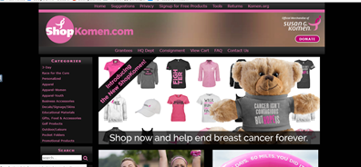

- Enter your email address.

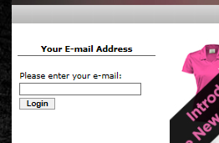

- Enter your Grantee access code. Your Grantee access code is SGKGRANTEE2017.

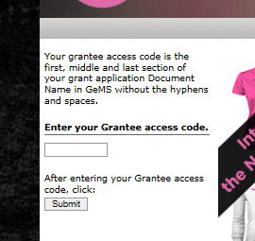

- Confirm your email address.

- Complete New User Registration. On your first visit to ShopKomen in the new grant year, you will need to register. On your next visit, you will be asked to follow steps 1-3 above.
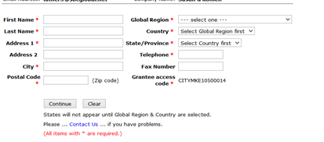
- Click ‘educational materials” on the left rail to find the Breast Self-Awareness Messages cards.
